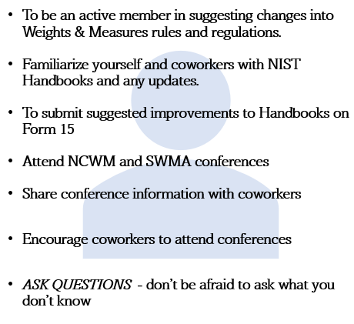  Membership Responsibilities  Member States  Alabama, Arkansas, Delaware, Florida, Georgia, Kentucky, Louisiana, Maryland, Mississippi, North Carolina, Oklahoma, South Carolina, Tennessee, Texas, Virginia, West Virginia, the District of Columbia, and the U.S. Virgin Islands.  Membership Types  Active Member  •Resides in member Jurisdiction  •Employed by State, County, City  •Voting delegate  •May hold office and be a committee member  Associate Member  •Person having interesting in weights and measures work  •Has a voice in all proceedings, but no vote  •May be a committee member  Advisory Member  •Representative of Federal Government, State, and local governments  •Retired persons who are interested in weights and measures work |  |  | Who We Are  About Us  The Southern Weights and Measures Association (SWMA) is a corporation organized as a not-for-profit business to encourage uniform weights and measures enforcement methods.  Contact Us  Membership Education & Mentorship Subcommittee  Matt Curran matthew.curran@fdacs.gov  Tory Brewer tory.d.brewer@wv.gov  Lisa Corn lisa.corn@texasagriculture.gov  Valerie Forbes valerie.forbes@delaware.gov  Christina Osborn christina.osborn@texasagriculture.gov  Paul Floyd pfloyd@ldaf.state.la.us  Jason Glass jason.glass@ky.gov  Gary Milton gary.milton@vdacs.virginia.gov  Mark Lovisa mlovisa@ldaf.state.la.us  SWMA  https://www.swma.org |  |  | SWMA  - Southern Weights & Measures Association

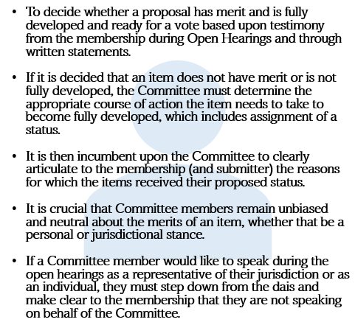  Committee Member Responsibilities  Standing Committees  Professional Development Committee  (PDC)  Ongoing education and certification of professional.  Specifications & Tolerances Committee  (S&T)  Evaluates issues related to design, testing, tolerances, and user requirements of commercial weighing and measuring devices.  NIST Handbook 44  Laws & Regulations Committee  (L&R)  Dedicated to the development of uniform basic and specific model laws and regulations as well as verification of net quantity in packages.  NIST Handbook 130  NIST Handbook 133  Each has 5 Active Members |  |  | Meeting Agenda  Looking to get more involved?  Have more questions?  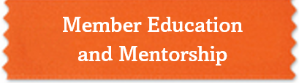Come find us!  Sunday  New SWMA Membership Orientation  New SWMA Committee Member Orientation  Committee Agenda Review Session  President’s Reception  Monday  Open Hearings  Committee Work Sessions  Tuesday  Committee Work Sessions Continued  Planned Group Outing  Wednesday  Voting Session  Closing Ceremony – Passing of the Gavel |  |  | 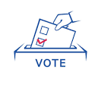  Statuses of Agenda Items  Voting  Fully developed and ready for a vote by the SWMA Membership  Informational  Deemed to have merit and sufficient information for consideration but need more time for input. Committee owns the item and is responsible for further refinement.  Developing  Deemed to have merit but lacking enough information for full consideration. The submitter owns the item and is responsible for developing it.  Assigned  Deemed to have merit but lacking enough information for full consideration and is assigned by the committee to a specialized subgroup, who owns the item and is responsible for developing it.  Withdrawn  Found to be without merit and have not had sufficient development to be given further consideration.

