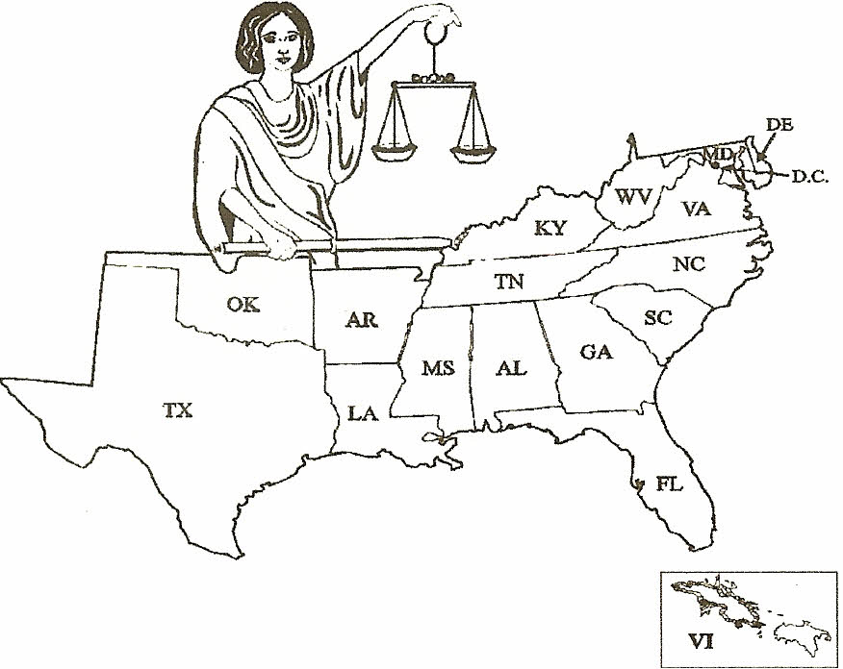

Southern
Weights & Measures
Association

165th Edition SWMA Newsletter January 2023

Happy New Year Everyone!

Louisiana
Well, it looks like our motor fuels inspectors are going to have a few more devices to inspect once the new Buc-ee’s opens in Ruston, Louisiana. If you don’t know, Buc-ee’s stores are giant gas station / convenience stores. The location in Luling, Texas is 75,000 square feet and has 120 fueling positions! Throw in a few scales for beef jerky, candy, and food sales, and lots of point-of-sale scanners and an inspector has a few days of work ahead of them. Welcome to Louisiana, Buc-ee's!
In other news, Richert Williams retired after 30+ years of service heading our Metrology lab. Whitney Corley has taken on the role of Metrology Program Manager and Jenny Adair has moved into Whitney’s Metrologist role. Tyler Holmes has come on board recently to work in both the Metrology and Motor Fuels labs. Tyler will start his Metrology training with NIST soon.
EVSE
Our field staff did a sweep of their respective areas looking for and verifying EVSE charging stations. The field staff used a combination of web searches, smart phone app searches, and their own recollection of the locations that they had seen while in their own territories. They have compiled a list of 188 locations in the state with a total of 552 charging points. Many of the locations were indicating additional charge points to be added in the very near future. Of the 552 charging points, 101 were listed as free. Some of these also indicated that they will convert to charging for the services in the future.
Price Verification
LDAF Commissioner, Mike Strain DVM, was recently interviewed by Barron’s concerning incorrect pricing concerns in Louisiana and other states. The story should be available soon.
It’s been speculated that inflation and a shortage of workers has created more pricing problems over the past year. Louisiana has seen a 160.73% increase from 2021 to 2022 in the number of overcharge violations per case in those cases that were brought before the Weights and Measures Commission for a hearing. That’s a 310.98% increase in overcharges overall! We’ve also seen a 193.3% increase in the number of cases brought to hearing resulting in a 280.6% increase in total dollar amount of fines assessed.
We work for equity in the marketplace. With increasing prices and more frequent price changes, this is becoming more difficult. Consumers seem to be paying more attention to the prices they are charged compared to what is advertised. Even more in these times where it is tough on business to keep up, consumers are looking to us to maintain that equity in the marketplace.
Scales
Inspectors have been working tirelessly inspecting scales small and large throughout Louisiana in an effort to catch up some areas that fell behind last year. We’ve had two more light duty inspectors obtain CDLs so that they can help in the rapidly expanding Heavy Duty Program. In fact, our HD program has seen so much growth over the last few years that we could just about devote another inspector to it entirely in southeast Louisiana. In the past year we have seen many additions and upgrades to weigh in motion rail scale operations, mass flow meter loading facilities, and livestock scales with several more large scale upgrades already on the calendar. Our inspectors definitely have their hands full.
Paul Floyd

Florida
- Much like other states have reported, we have seen a sharp increase in Price Verification violations and have been concentrating on increasing inspections in this area and in Net Contents inspections.
- After a more than a year on the waiting list, the bureau finally received 12 new vehicles to replace the oldest ones in our fleet, it is a far cry from the 26 we were approved for but are happy to get even this small number of new vehicles!
- Even though we have seen a slight improvement in the number of qualified applicants, we are still experiencing high turnover and hiring issues, with this comes the increased need for comprehensive training of new inspectors.
- We are currently undergoing the transition to a new Commissioner of Agriculture as Commissioner Wilton Simpson was sworn into office on January 3. We are excited about working with Commissioner Simpson and are looking forward to some great improvements in the department in the coming days.
- Slowly but steadily, the Bureau of Standards continues working in conjunction with NIST (OWM) to perform initial testing and development of protocols in the use of Coriolis (master meters) to test CNG dispensers.
- In the weeks following hurricane IAN’s wide path of destruction and flooding, the Bureau of Standards responded by mustering our inspectors to check for water intrusion in underground fuel tanks and assessing damages to facilities including gas stations and LP Gas installations.

Hal Prince

Oklahoma

I hope all is well with you. Here in Oklahoma its pretty much business as usual for Weights and Measures. Nothing really to report other than we are getting ready to start checking of Ranch Scales throughout our state in late Spring. Stay safe.
Gary Smith

North Carolina
In the Fall we got down to only having 2 vacant positions in our 90 person staff, that has since exploded to 13, with our programmer, Susan Myrick, retiring in January after 25 years with us. Our Administrative Officer left in November, with most other positions being in Metrology and Fuel Quality. Getting qualified applicants has been a struggle and with vacancies in our HR office the process has been slowed a bit.

LP-Gas Section

10/25 – 27; The second draft meeting for NFPA 30A, Code for Motor Fuel Dispensing Facilities and Repair Garages, was held to consider the remaining proposals. Much of the time was spent addressing safety issues concerning electric vehicle recharging stations at stations for liquid fuels. These were not addressing method of sale. Richard Fredenburg, our LP-Gas Engineer participated in the meeting.

Throughout the quarter – Questions and discussions concerning return-to-zero interlocks for retail motor fuel devices dispensing propane. This may be settled early in 2023 with actions by NCWM interim meeting in January. That said NC fuel tax laws in our Department of Revenue will be a factor also.

Measurement Section

Greetings from the Tarheel state, North Carolina.
My section has been lucky and not had too many open positions to fill. It is becoming very difficult to hire, with wages continuing to climb and the labor market still slim. We were able to fill one fuel dispenser position. Alex Norkett accepted the position and is currently going through training. Our other position needed to be reposted and is still in the HR process.
We just received two trucks and we are waiting on the G&O bodies to be transferred over. How come after covid it takes forever to get anything done? Our failed scans and the news media surrounding that, are keeping us very busy. It’s a vicious cycle that keeps going round.
God Bless,
Chad Parker

Mississippi
Womack named State Chemist, director of the Mississippi State
Chemical Laboratory
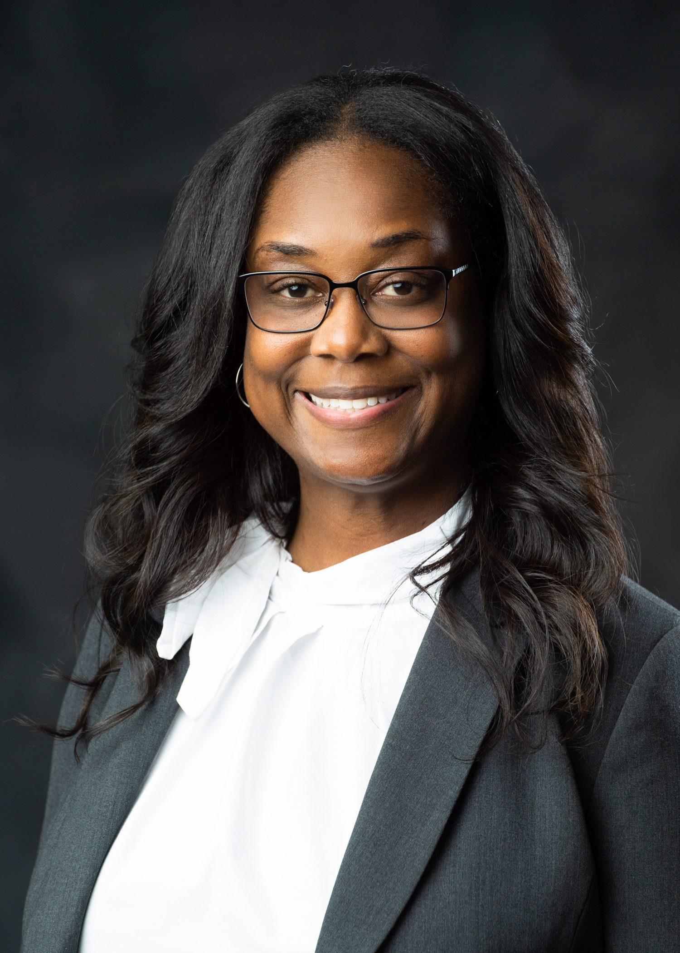
Womack leads the Mississippi State Chemical Laboratory
Starkville, MS— 12/1/2022 —After a nationwide search, Dr. Erika Womack has been named director of the Mississippi State Chemical Laboratory and State Chemist of Mississippi. Womack will serve as the 12th State Chemist of Mississippi, succeeding Dr. Darrell Sparks who was named interim State Chemist in 2021 and served as associate State Chemist from 2017-2021 and Dr. Ashli Brown, the first woman who was appointed as State Chemist from 2013-2021.
Womack first came to the Mississippi State Chemical Laboratory in 2011 as a graduate student at the Mississippi State University. She was trained as an analytical chemist alongside laboratory staff while completing a doctoral degree in molecular biology. Prior to this academic achievement, Womack also obtained a master’s degree from Mississippi College in biomedical sciences in 2007 and was employed as a researcher with the University of Mississippi Medical Center in the Department of Orthopedic Surgery and Rehabilitation for eight years examining the genetic basis of idiopathic scoliosis in the pediatric population. Womack conducted research for crop improvement as a post-doctoral Genetic Scientist with the USDA-ARS’s Corn Host Plant Resistance Research Unit in Starkville, MS from 2016-2019 before serving as a research laboratory manager in the Department of Physical Medicine and Rehabilitation at the University of Alabama at Birmingham.
The Mississippi State Chemical Laboratory, an ISO/IEC 17025:2017 accredited laboratory, has 130 years of service dedicated to the state of Mississippi. A state-appropriated agency that supports the stakeholders of Mississippi’s agriculture, the Mississippi State Chemical Laboratory shares regulatory authority of animal feeds, fertilizers, pesticides, agricultural limes, human foods and petroleum products with the Mississippi Department of Agriculture and Commerce, Bureau of Plant Industry, Mississippi Department of Health, and the State Department of Marine Resources.
“I am extremely grateful for the chance to lead the Mississippi State Chemical Laboratory. The lab has immense analytical capabilities and offers a critical service for the advancement of agriculture, support of industries and stakeholders, and for the protection of consumers in the state,” Womack said. Her appointment as State Chemist is pending confirmation from the Mississippi Senate.

For more on the Mississippi State Chemical Laboratory, visit www.mscl.msstate.edu.

The Mississippi Department of Agriculture and Commerce (MDAC), Bureau of Regulatory Services, works closely with the State Chemist, in many different capacities. The Petroleum Division, Consumer Protection Division and the Meat Inspection Division all rely on the Office of the State Chemist for testing samples that are obtained by the various regulatory divisions.
The MDAC petroleum division obtains complaint as well as random samples from retail locations throughout the state to test for fuel quality. Gasoline, Ethanol blended gasoline, diesel, biodiesel and kerosene are all tested by the State Chemist and the results are relayed to the petroleum division so that corrective action can be taken to ensure all “out of spec” product is placed “off sale”.
The MDAC consumer protection division obtains complaint honey samples that are tested for adulteration, typically containing syrup and other non-honey ingredients, by the State Chemist. In addition, catfish can be tested to determine actual fish species as well as testing for pesticides as well as minerals.
The MDAC meat inspection division works with the State Chemist to conduct economic sampling. Economic sampling tests meat products for salt content, fat content, protein content and water content.
So, the office of the State Chemist plays an integral part of the day-to-day job functions of the Mississippi Department of Agriculture and Commerce Bureau of Regulatory Services. The Bureau is proud to partner with the State Chemist to ensure that all citizens of Mississippi are protected.
The department continues with staffing issues when attempting to fill inspector positions.
Jennifer Thompson

The SWMA Newsletter is published quarterly: Annual dues are $50.
Membership inquiries should be directed to: Stephen Benjamin, SWMA Secretary-Treasurer
NC Department of Agriculture & Consumer Services, 1050 Mail Service Center, Raleigh, NC 27699-1001
Phone: 984-236-4755
E-Mail: steve.benjamin@ncagr.gov , Website: http:www.swma.org
News may be submitted to: SWMA, 1050 Mail Service Center, Raleigh, NC 27699-1001, E-mail: steve.benjamin@ncagr.gov

